

**School of Engineering and Applied Science,**

**Ahmedabad University**

**CSE300 Software Engineering**

**Weekly Report**

**Guided By: Prof Khushru Doctor**

**TA Muskan Matwani**

**TA Anupama Nair**

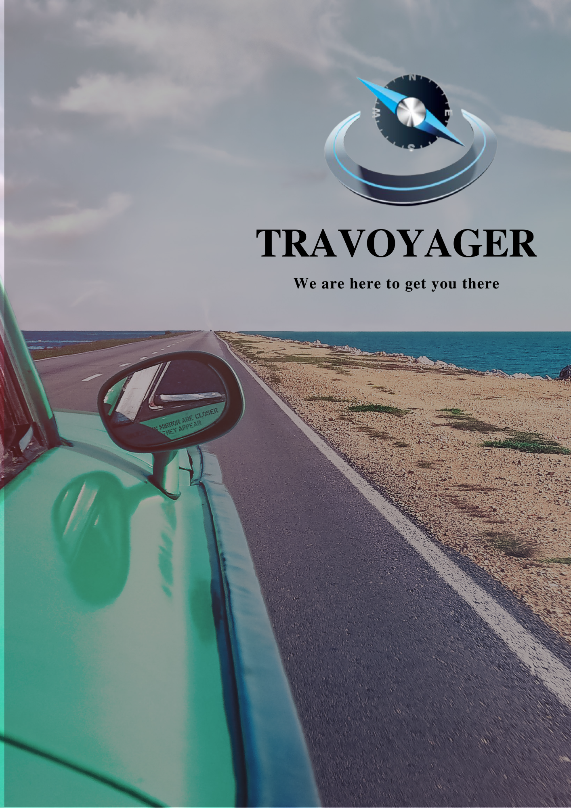

**WEEKLY MEETING REPORT - 5**

**Agenda** - Sprint Formulation and ER Diagram Construction

**Date and Time**

**________________________________________________________________________________________________________________________________________________________________________________________________________________________________________________________________________________________________________________________________________________________________________________________________________________________________**

March 7, 2021 04:00P.M.-5:30P.M.

**Location**

**________________________________________________________________________________________________________________________________________________________________________________________________________________________________________________________________________________________________________________________________________________________________________________________________________________________________**

Google Meet

**Schedule**

**________________________________________________________________________________________________________________________________________________________________________________________________________________________________________________________________________________________________________________________________________________________________________________________________________________________________**

|  |  |
| --- | --- |
| **Time** | **Description** |
| 4:00-4:05 P.M. | Attendance |
| 4:05-4:30 P.M. | Sprint Formulation |
| 4:30-5:00 P.M. | ER diagram content |
| 5:00-5:25 P.M. | ER diagram construction initialisation |
| 5:25-5:30 P.M. | Summary |
| 5:30 P.M. | Meeting Adjourned |

**Details**

**________________________________________________________________________________________________________________________________________________________________________________________________________________________________________________________________________________________________________________________________________________________________________________________________________________________________**

As per discussion within the team and the requirement of the project, the sprints decided are as follows:

1. S1: Decide the features of frontend(screen design + flow of the screens) as well as backend(database design + ER diagram completion)
2. S2: Design the login/signup screen + home screen and create the database
3. S3: User input screen design and functionalities
4. S4: Generating the itinerary and displaying it to the user
5. S5: Hotel and travel options availability display
6. S6: Dynamic nature in the project to be added + payment options for the user
7. S7: Any changes if required and final documentation

**ER Diagram**

The tentative entities decided to be included in the diagram are as below:

1. Travoyager System
2. User
3. Destination
4. Itinerary
5. Hotel
6. Place
7. Transportation

**Conclusion**

**________________________________________________________________________________________________________________________________________________________________________________________________________________________________________________________________________________________________________________________________________________________________________________________________________________________________**

As per the sprints decided, frontend and backend teams were assigned the tasks accordingly for Sprint 1 a rough ER diagram was formed. Beginning of Sprint 1.

**Next Meeting Details**

**________________________________________________________________________________________________________________________________________________________________________________________________________________________________________________________________________________________________________________________________________________________________________________________________________________________________**

March 14,2021 , 4:00-4:45 P.M.

**Next Agenda**

**________________________________________________________________________________________________________________________________________________________________________________________________________________________________________________________________________________________________________________________________________________________________________________________________________________________________**

Sprint 1 Discussion